CS777_Assignment4_report_Lin_Chen

Task1:

I got the TF-IDF vectors of the big dataset and the Test dataset firstly.

Then, I calculate the average TF value of the five words:

[“applicant”, “and”, “attack”, “protein”, “court”]

For Au files and Wiki documents by using filter() and map().collect().

The result is as follows:

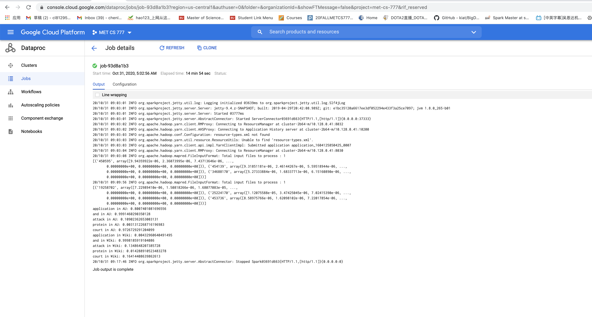

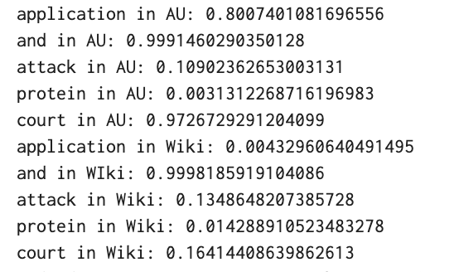

We can see clearly that the ‘applicant’, ‘court’ have the larger average values of TF in AU files than in the Wiki files. And both two documents have large average value for ‘and’.

Task2:

Firstly, I use the small train dataset on my laptop to construct the model and train the model. I implement it without regularization first and then add the L2 regularization as penalty items. The thing I noticed most is the cost value, I concentrate on the cost value whether or not it decreases as the training progress.

At this task, I found that we can’t set the default value of the parameter of L2 regularization (lambda) too large. The bigger lambda can cause the larger cost value and even cause the cost value can’t convergence as expected. I have tried a lot of lists of lambda value as lambda= [100,50,20,10,1,0.1,0.001,0.0001,0.00005,0.00001].

Then I found the lambda =0.00001 can get the best results that is the small cost value and can convergent at the local minimal.

Another important thing for this task is the learning rate, I use the Bold River to change the learning rate dynamically as the cost decreasing. We all know that learning rate is an important parameter in machine learning and the value of it is similar as the step size. If we didn’t change the step size dynamically, it may fluctuate at the local minimal.

Then, the l2 norm of the difference is also important, and we should choose the proper value for it. If the difference is too large, it means the stop condition for iteration is too loose and we can’t get the optimal model for use, it may result in the low accuracy and low f1-score. However, if the difference is too small, it means the stop condition for iteration is too strict, which may result in the infinite iteration of the program, because the difference of l2 norm of the regression parameters R can’t satisfy the condition at all. I have selected a lot set of the value of l2 norm difference as [0.00001, 0.0001,0.005,0.05,0.1,1] and I also notice that, the regression parameter is related to the L2 regularization parameter lambda and the gradient. So, we need to turn the parameter together with the lambda (L2 regularization parameter) and the stop condition L2 norm differences. Follows are some of my failure tasks as the comparison experiments to turn the parameters.

Experiment1: without regularization, that means lambda=0, and the difference I set =0.0001.

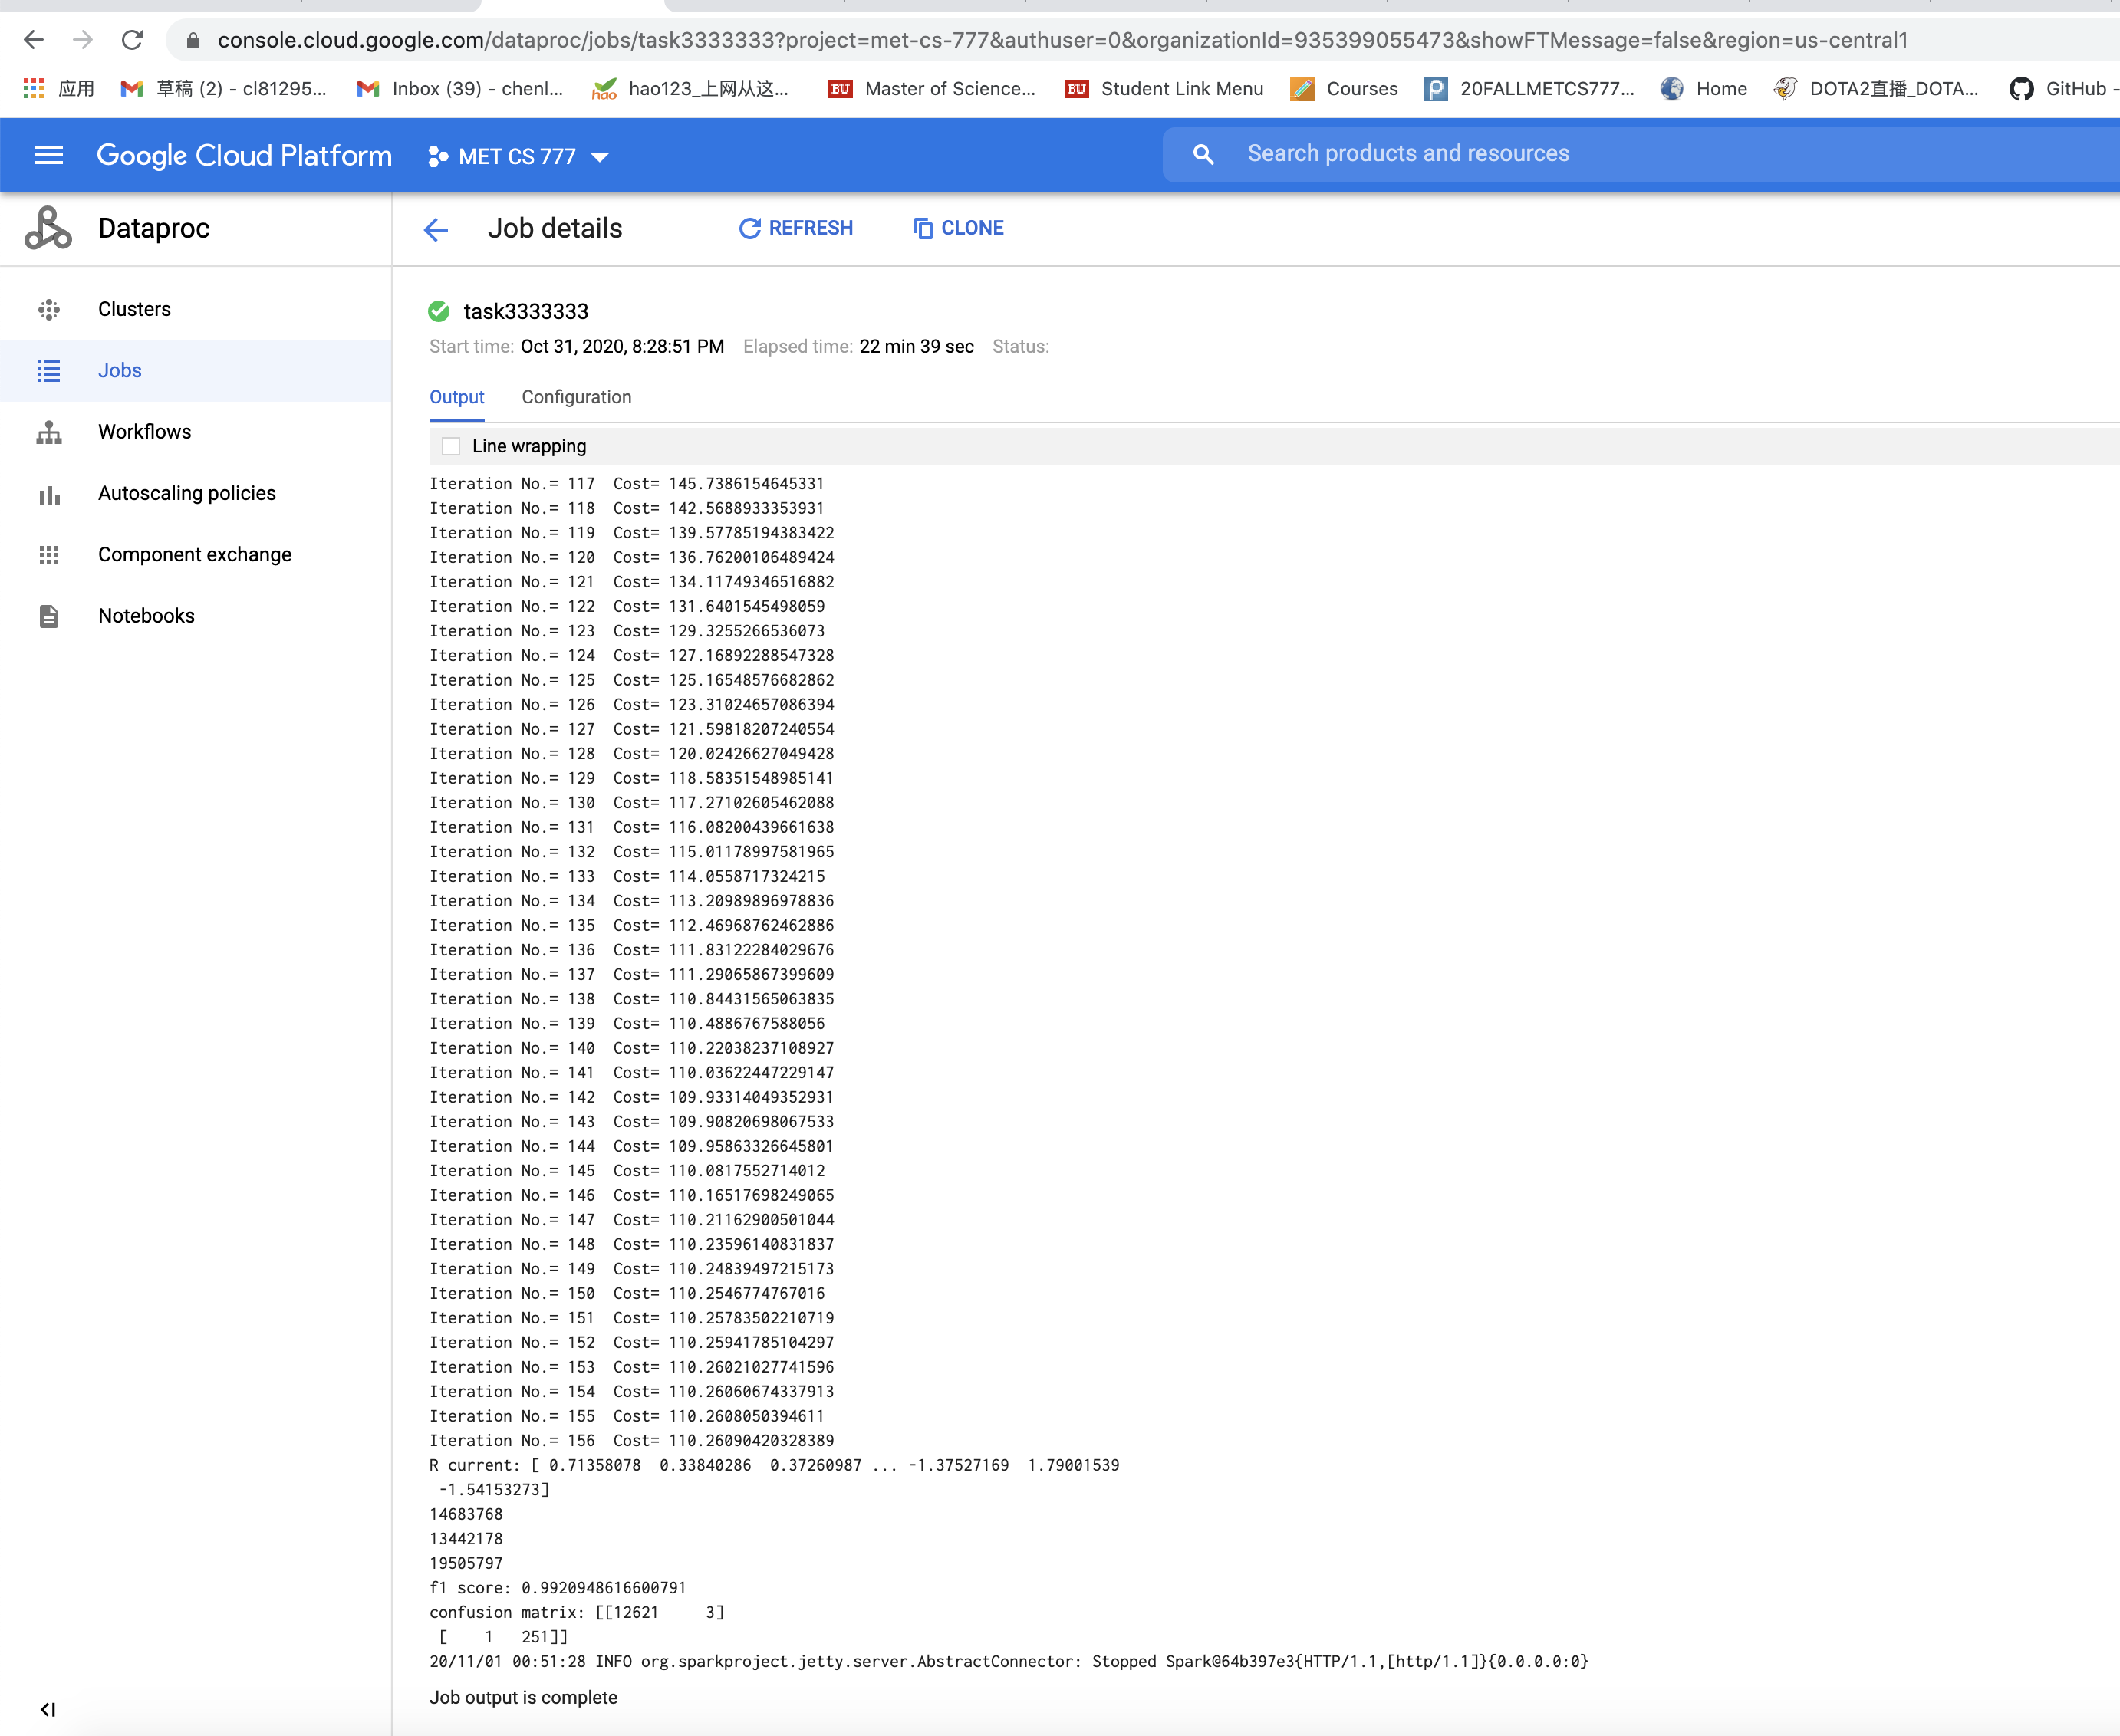

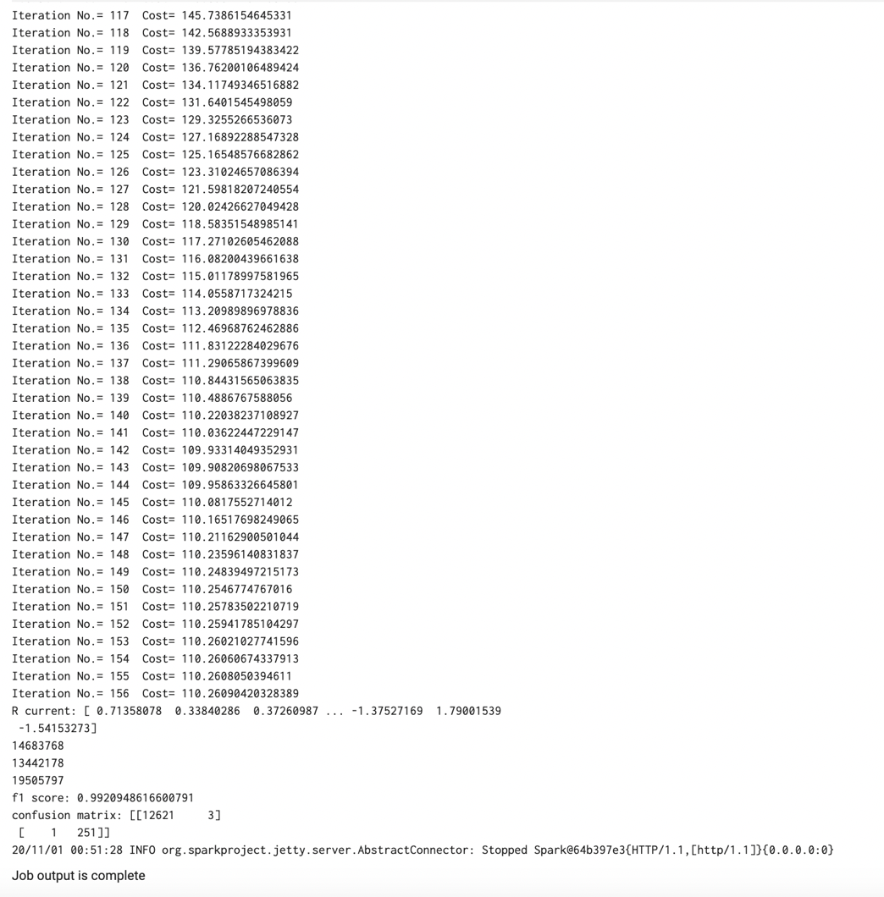

We can see that I can get a very good results with f1 score=0.99 and only have 3 FP and 1 TP. And the cost can convergent at iteration 156, cost=110.26. Therefore, without regularization and difference=0.001 can get a good result.

Experiment2: with regularization and lambda= 0.001 difference=0.001. Failure

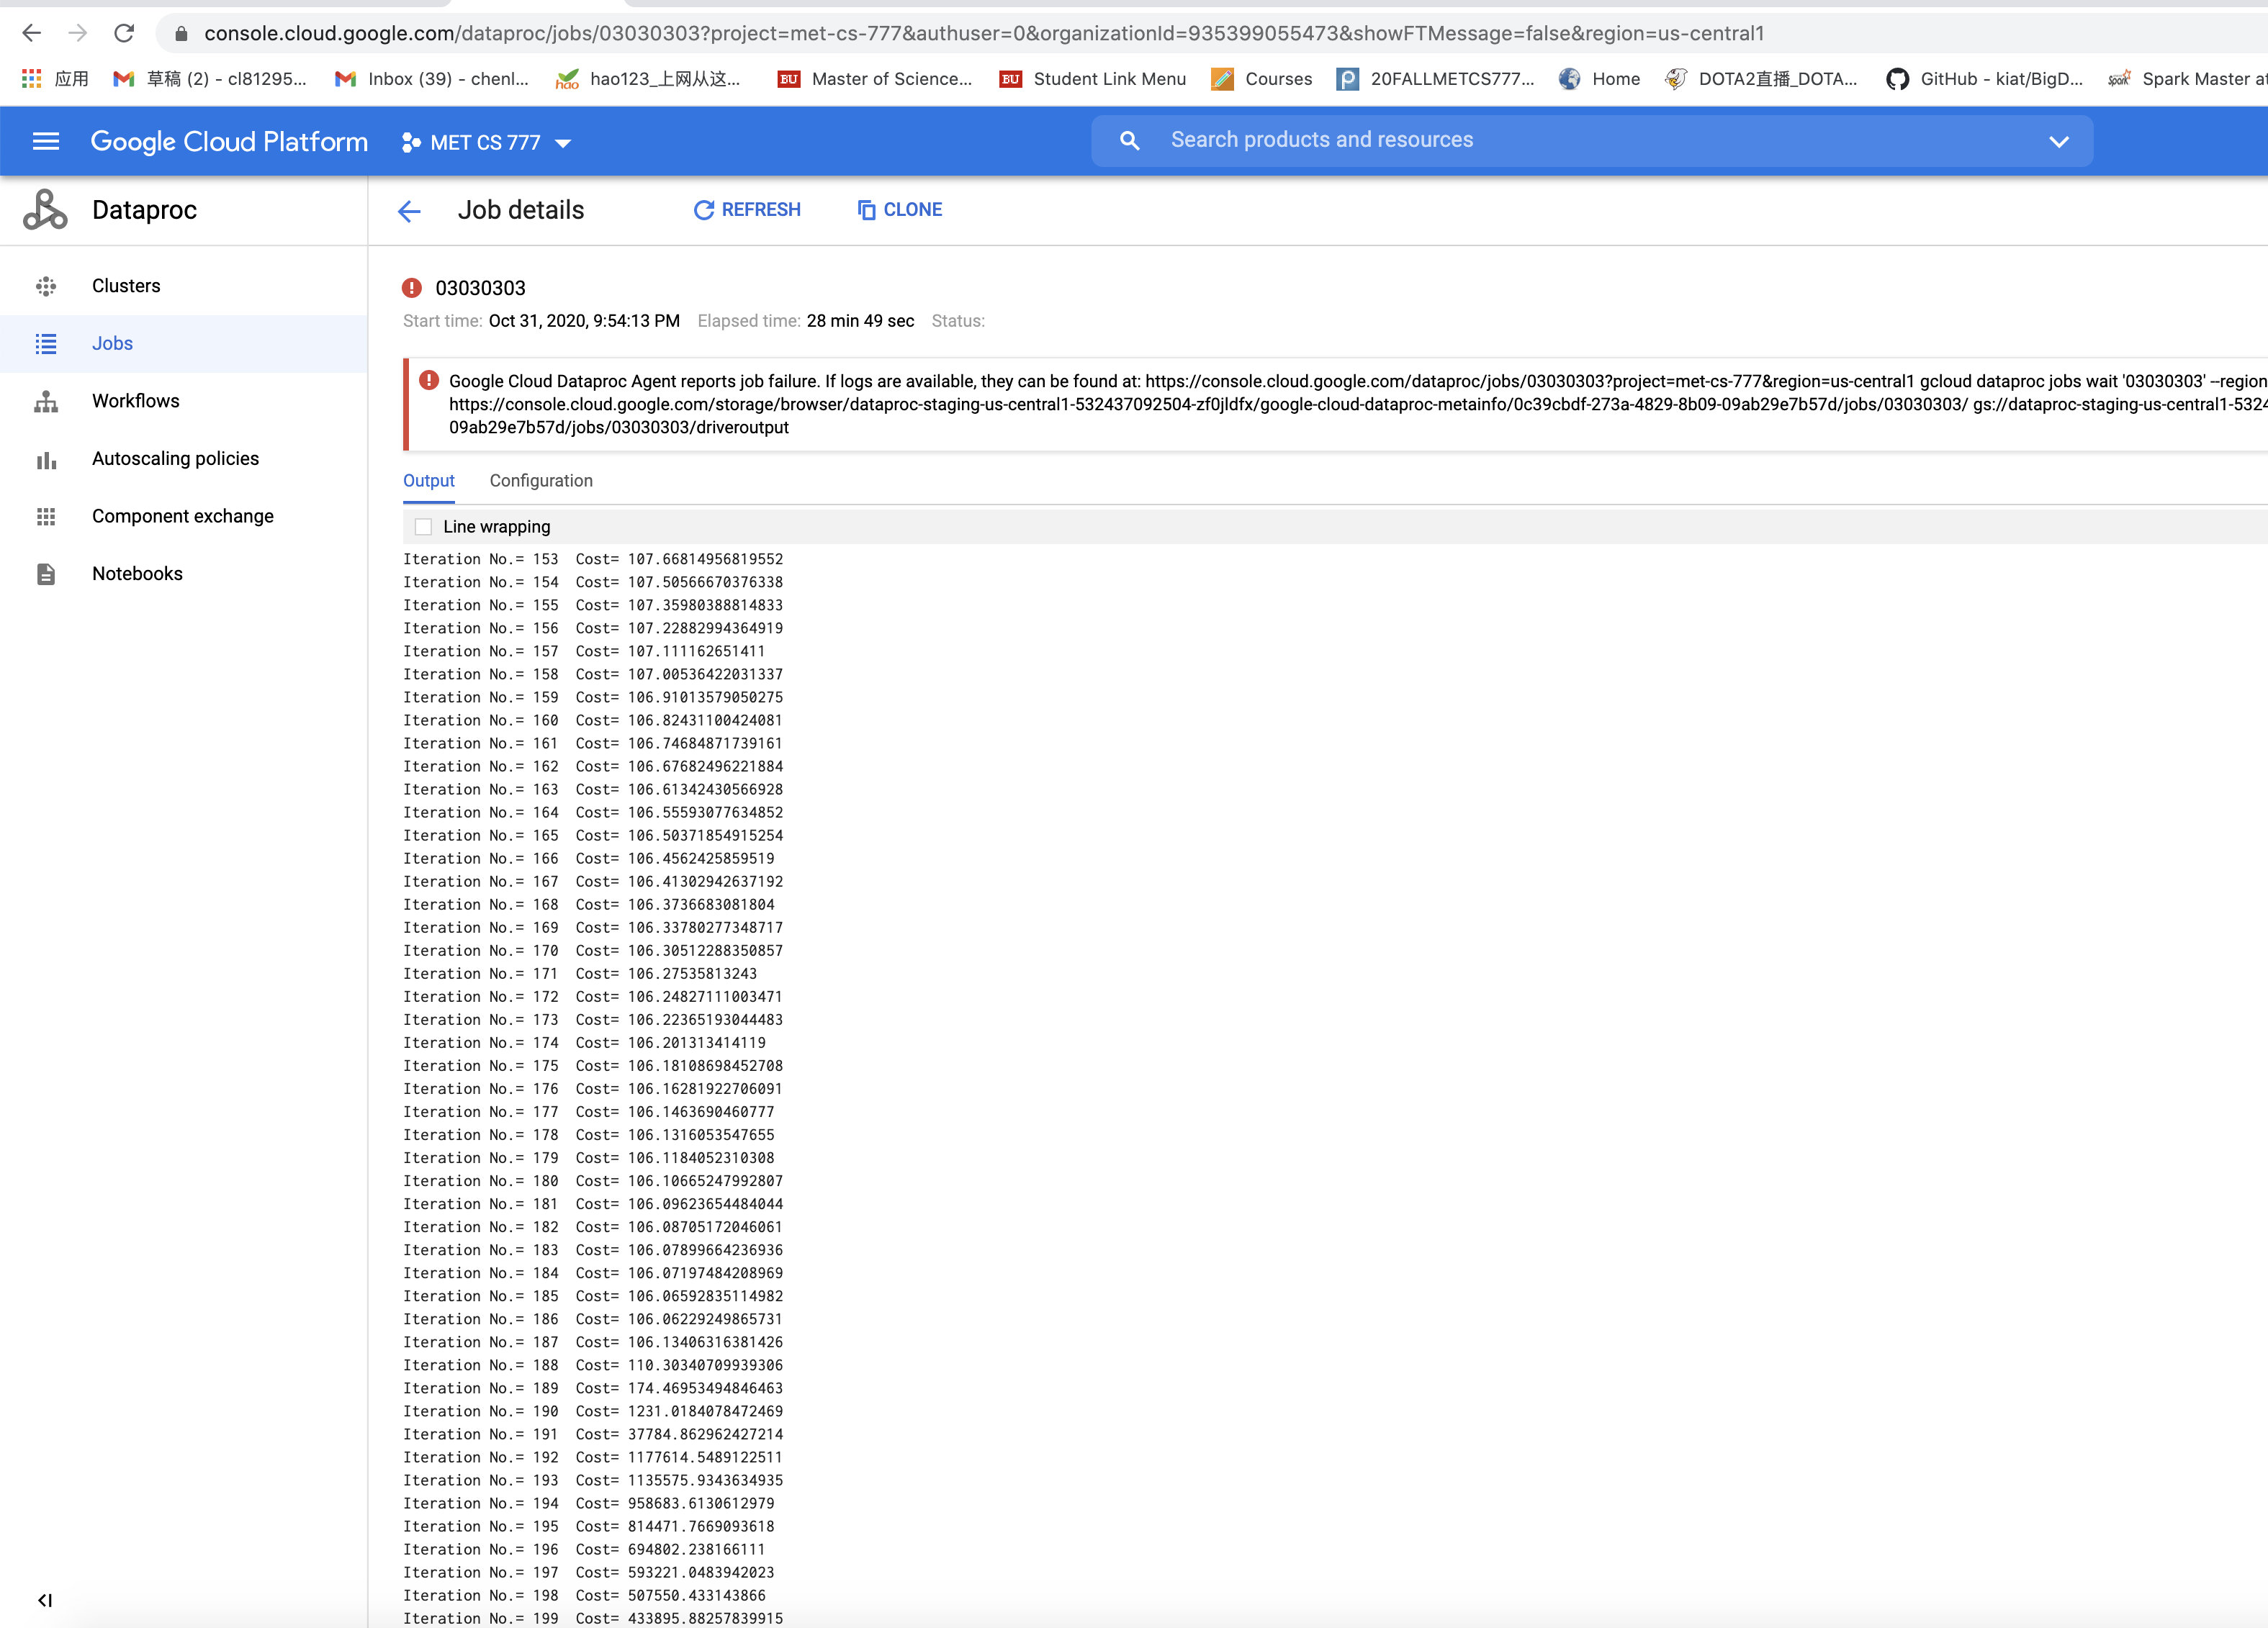

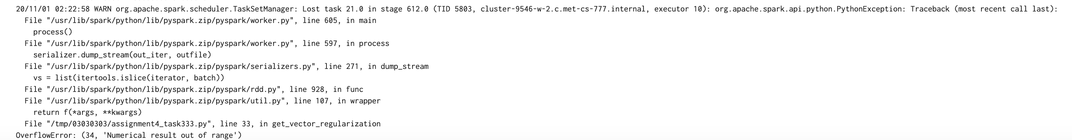

We can see that the cost value at this condition decreased to limit at 106.05 and then it increased fast and resulted in the booming divergence that caused the out of range error. I think the reason for this is lambda value is too large, so that we can’t get an optimal value of cost function, and the difference (stop condition) is too small, which means the stop condition is too strict. The training process didn’t stop when the cost value convergence at 106.05. Another important reason is that the learning rate is too large at the point of inflection, and we only multiply 0.5 to the old learning rate, it is also too large and cause the divergence. Therefore, we need to choose another clever method to turn the learning rate instead of the Bold River. However, we can also just turn the difference of the L2 norm, which is the stop condition to stop the training progress at this point with cost value =106.05.

Thus, I set another experiment3: lambda=0.0001 difference=0.0008

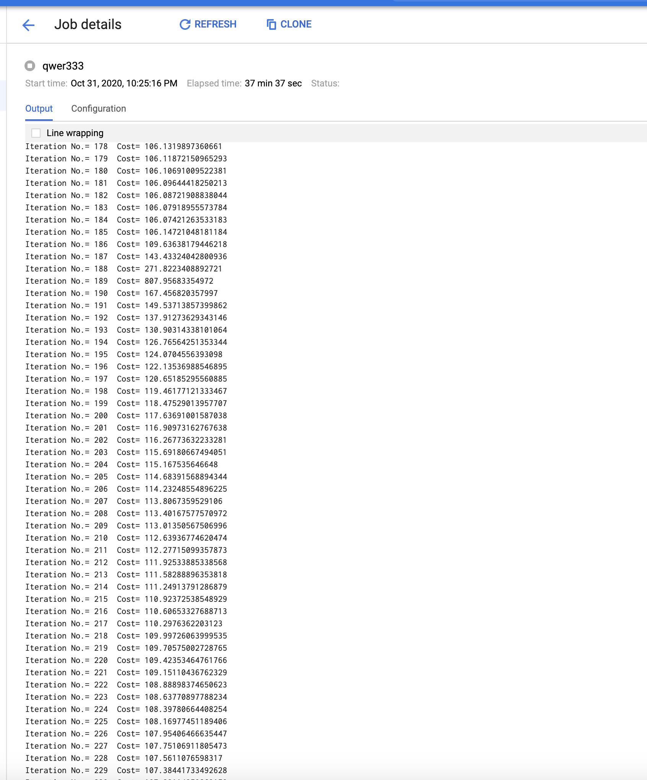

We can see this result is interesting that the cost value decreased first and convergent at cost value limited to 106 and then it increased fast and then it convergent to 106 again. I stopped this job at this time. The reason maybe the learning rate is too large and the difference of l2 norm is too small.

So, I set the experiment4: lambda=0.00001 difference=0.05

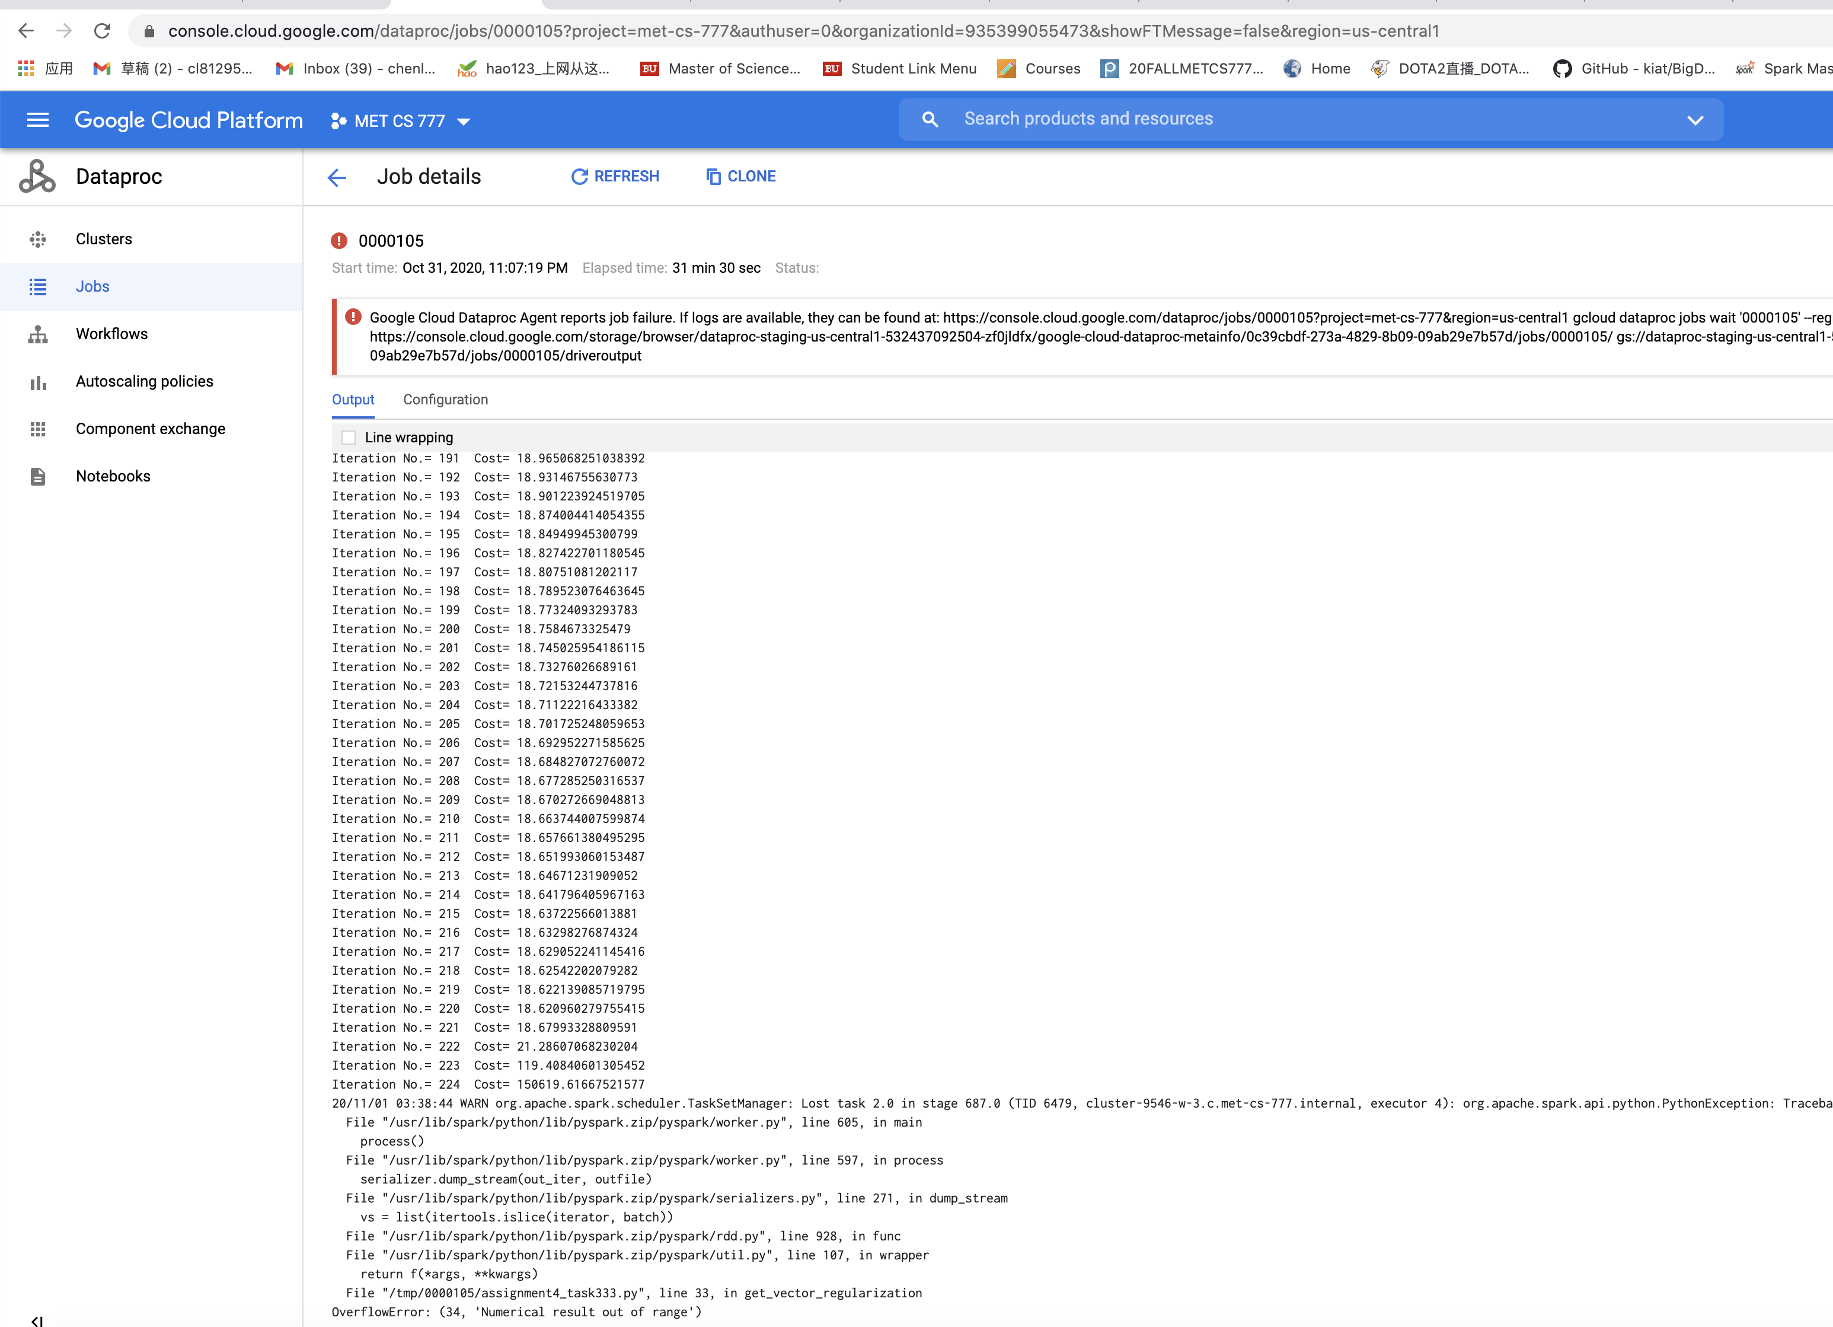

This is similar to experiment2, so I need to decrease the difference again.

Experiment5: lambda=0.00001 difference=0.1

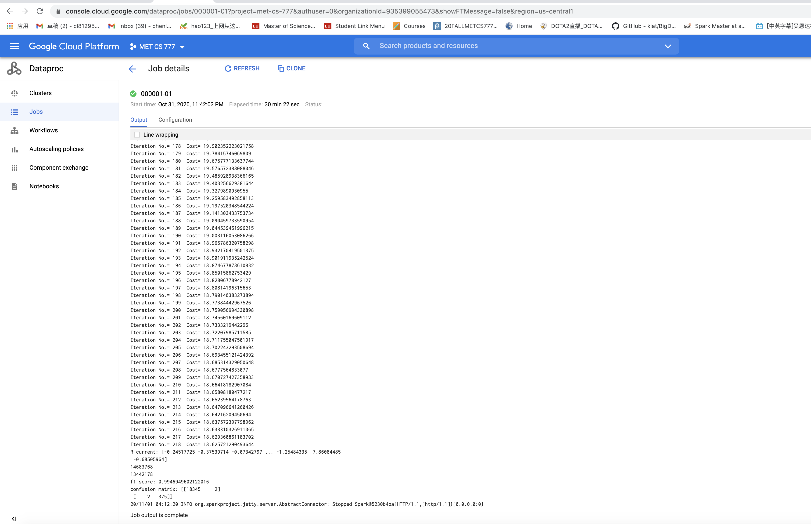

Finally, I did it, it succeed with these parameters.

The cost value has convergence at 18.625 and the F1 score is 0.99

It only has 2 FP and 2 FN, which means the model is so good.

Then I use the parameters of the model to print out the five words with the largest regression coefficients. That is, those five words that are most strongly related with an Australian court case.

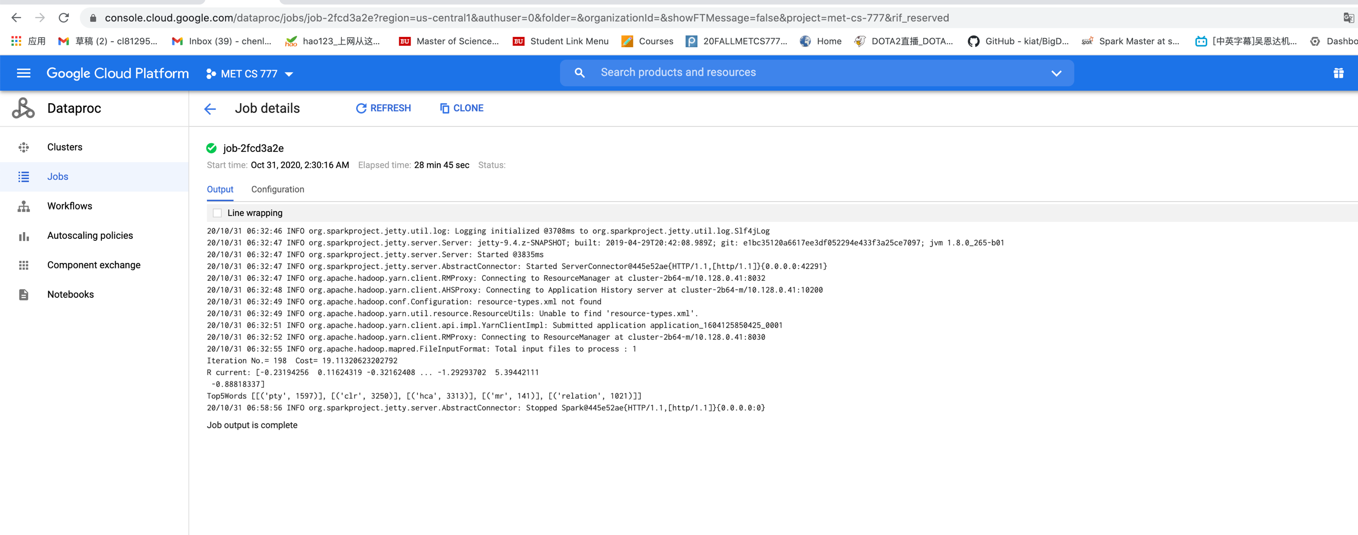

Task3:

First find the 2 FP doc ID in the Test dataset.

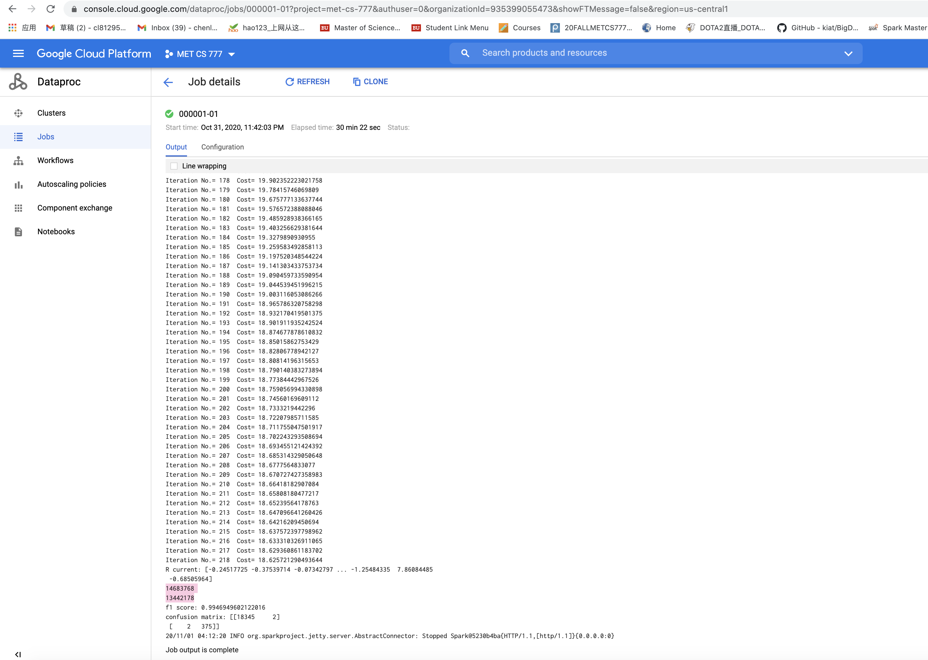

14683768,

13442178,

I use the Atom to open the Test data.txt, and find the 2 documents.

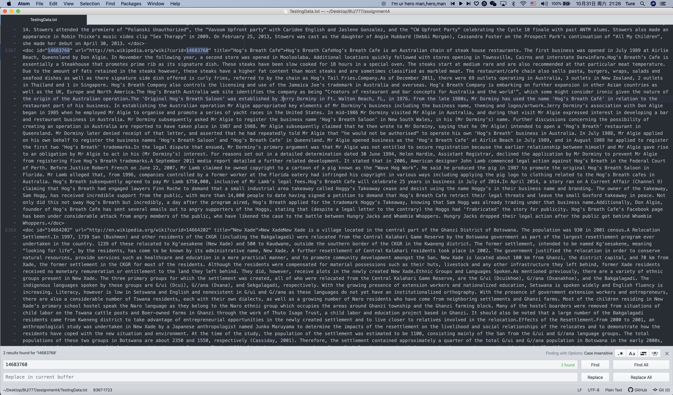

For the first FP document, that is 14683768, the document is Wiki document, but my classifier think it is AU court document.

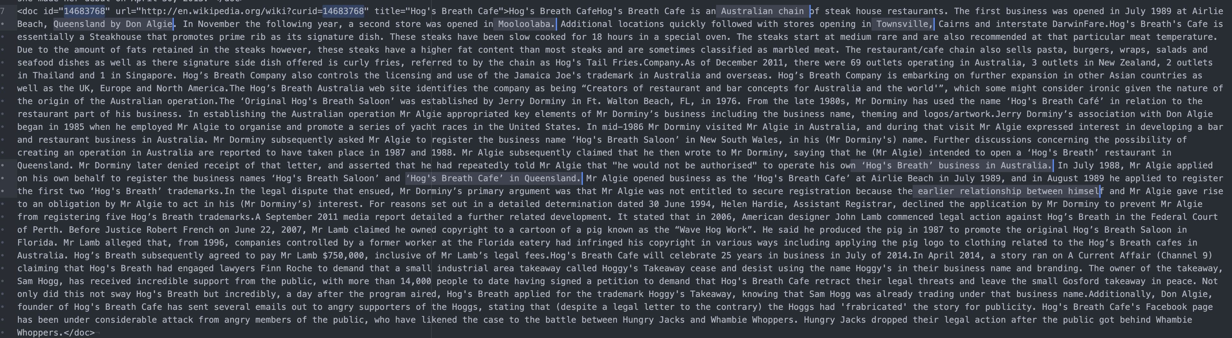

I have read carefully about this document, it describes the Café shop in Australia, which contains so many cities, addresses of Australia. So, my classifier was fooled and thought it is AU document.

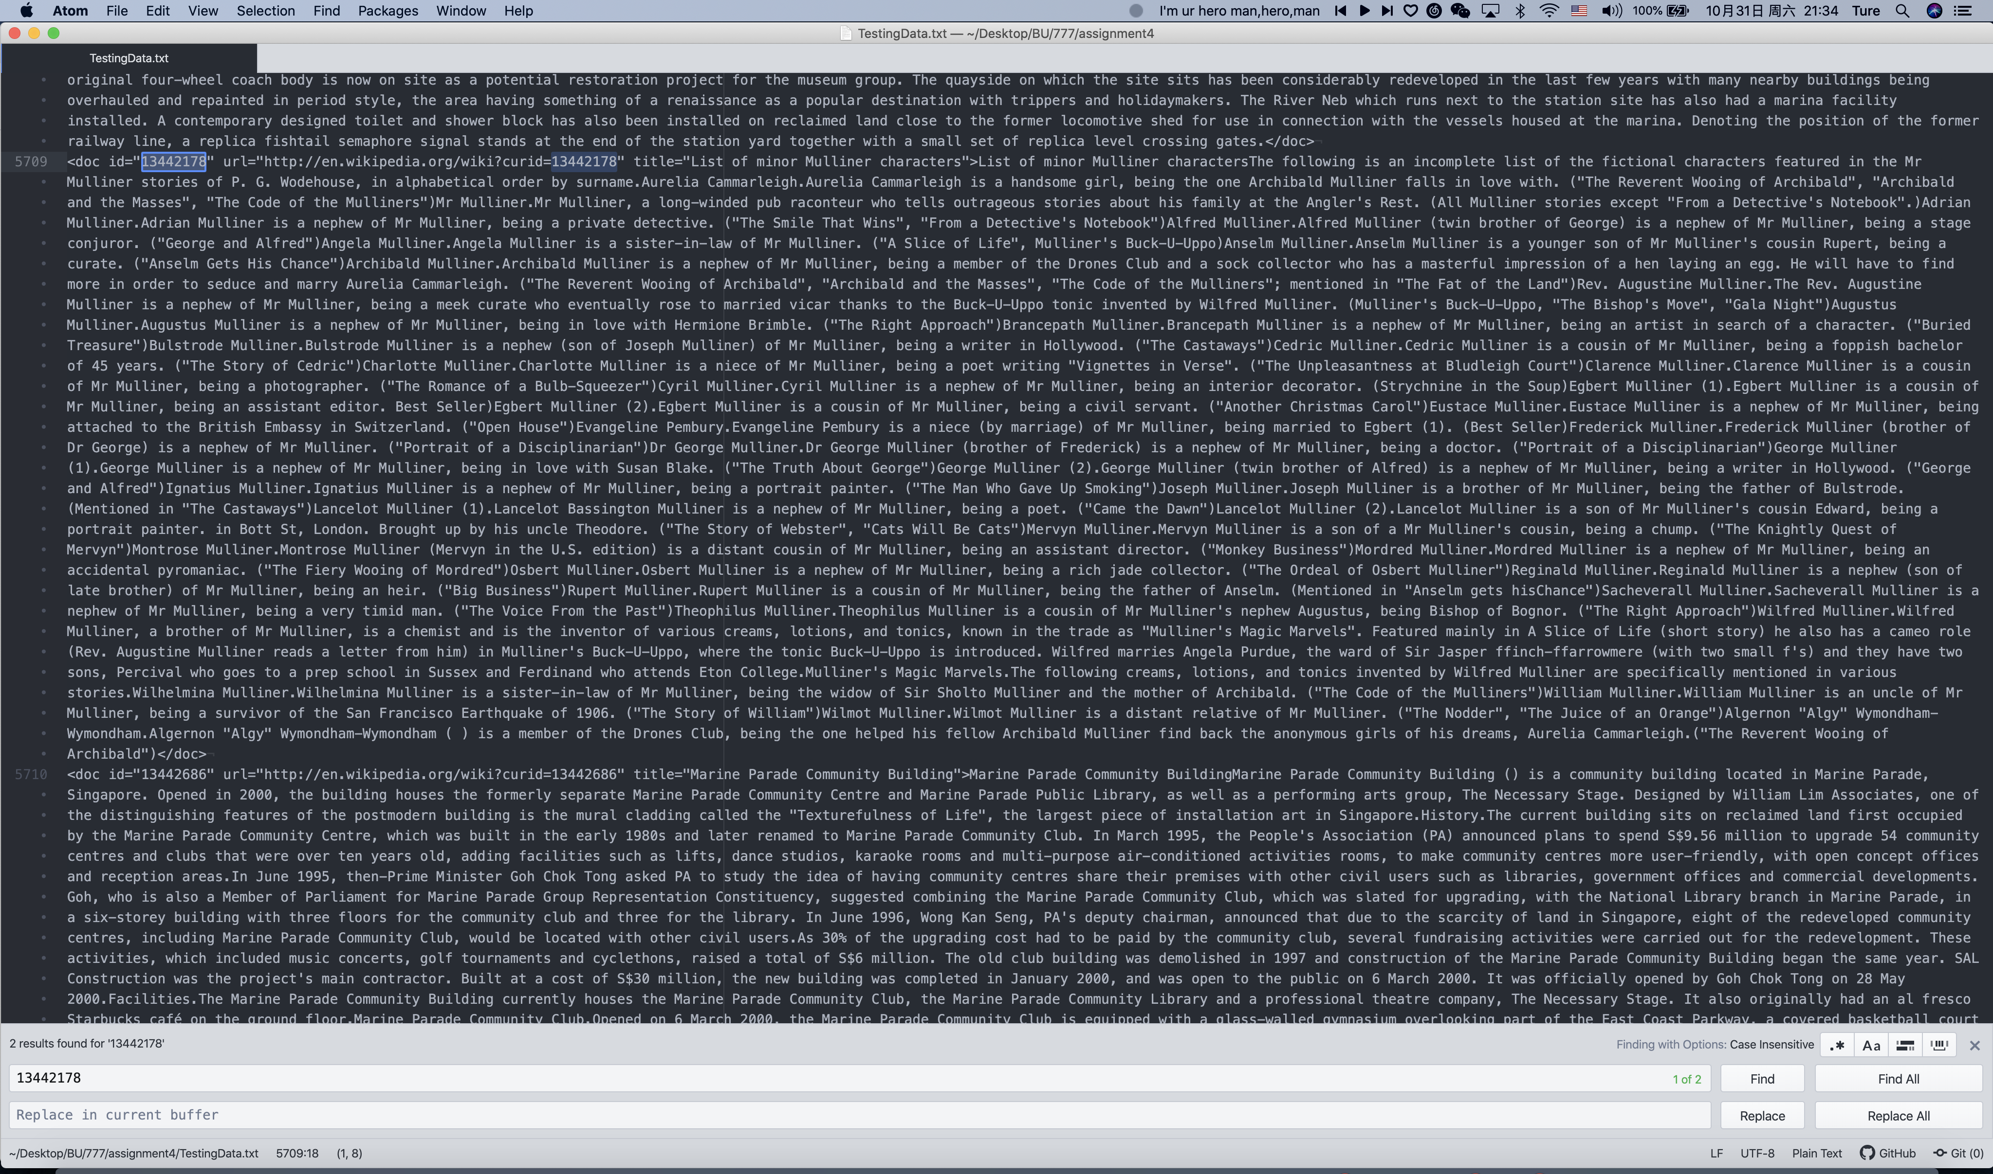

For the second FP document, that is 13442178, the document is Wiki document, but my classifier think it is AU court document.

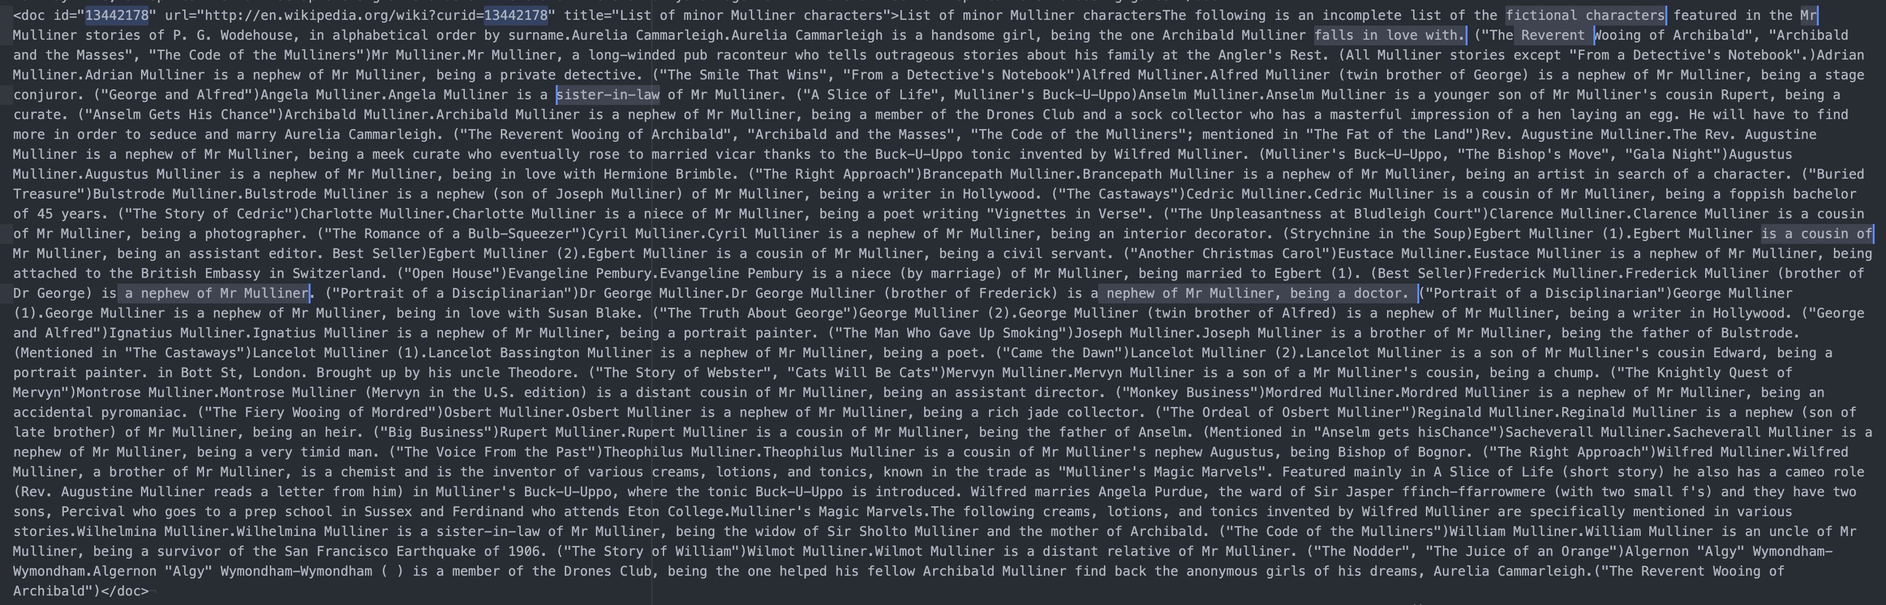

This document is about the relationship between the characters in the novel. There are many words that introduce the identity of the characters, such as 'Mr', 'relationship', 'sister-in-law', etc. These characters are often related to court documents. We have printed out the high-frequency vocabulary related to court in task2, and we will find that many words in it appear in this document. therefore, my classifier is fooled.